Configuring a CloudWatch Alarm for Lambda Invocation Errors with SNS Notifications

Lab Steps

Task 1: Sign in to AWS Management Console
- Click on the Open Console button, and you will get redirected to AWS Console in a new browser tab.
- On the AWS sign-in page,
- Leave the Account ID as default. Never edit/remove the 12 digit Account ID present in the AWS Console. otherwise, you cannot proceed with the lab.
- Now copy your User Name and Password in the Lab Console to the IAM Username and Password in AWS Console and click on the Sign in button
3. Once Signed In to the AWS Management Console, Make the default AWS Region as US East (N. Virginia) us-east-1.
4. Select Maybe later in the New AWS Console Home page pop-up.
Note: You will be provided with an IAM Role named sns_role_for_lambda that provides privileges necessary to execute the HELLO WORLD lambda function.

Task 2: Creating a "Hello world" function in Lambda
- Click on Services and navigate to the Lambda under Compute category.
- Make sure you are in the US East (N. Virginia) region.
- Click on the Create function button.
- Choose Author from scratch
- Function name: Enter Mytestlambdafunction
- Runtime: Select Python 3.8
- Role: In the permissions section, click on Change default execution role to choose to use an existing role.
- Existing role: Select sns_role_for_lambda
- Click on Create function
- Configuration Page: Here we need to configure our lambda function.
- If you scroll down a little bit, you can see the Function code section and paste the below code and save it.
import json
def lambda_handler(event, context):
# TODO implement
return {
'statusCode': 200,
'body': json.dumps({'message': 'HELLO FROM LAMBDA!'})
}
- Save the function by clicking on Deploy in the top right corner.

Task 3: Configure Test Event
- Click on the Test Dropdown button.
- In Configure test event page:
- Event Name: Enter snslambdatest
- Leave other fields as default.
- Click on Invoke.

Task 4: Configuring an Alert/Alarm in CloudWatch
- Click on services and navigate to the CloudWatch under Management & Governance.
- Click on All alarms under Alarms in the left panel and then click on Create Alarm
- Click on Select metric to choose the metric that will trigger our alarm.
- Choose “Lambda” from the All metrics section.
- Choose By Function Name.
- Check the error box for your function as shown in the below image:
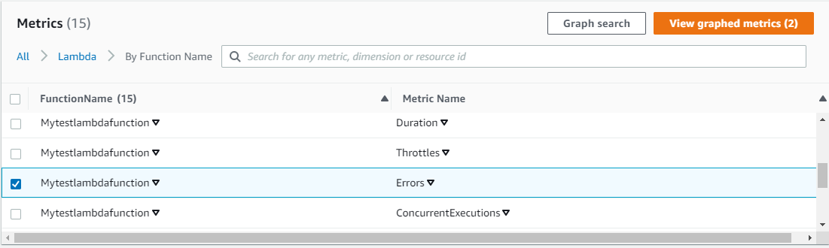
- Click on the Select metric button.
- Now fill the metric conditions with the following details:
  - Metric name: Errors
  - FunctionName: Mytestlambdafunction
  - Statistic: Average
  - Period: Select 1 minute
  - Conditions: Give the below details:
    - Threshold type: Select Static
    - Whenever Errors is: Greater/Equal
    - than... (Threshold value): Enter 0
  - Click on Next
- Configuring alarm using the below details in Notification :
- Whenever this alarm state: Select in Alarm
- Select an SNS topic: Select Create new topic
- Topic name: Enter lambdaexecutionerroralert
- Email endpoint name: Email address to which you want the alert to be sent (ex:test@example.com)
- Once completing the above details, click on Create Topic
- AWS will send a confirmation email to the email that you provided in the above step. Once you confirm the subscription, you will receive alerts from AWS CloudWatch.
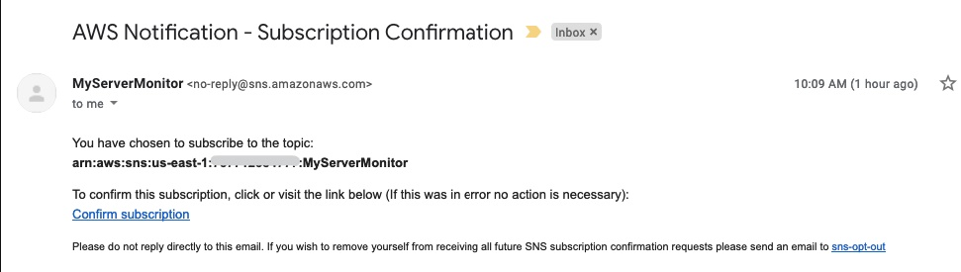
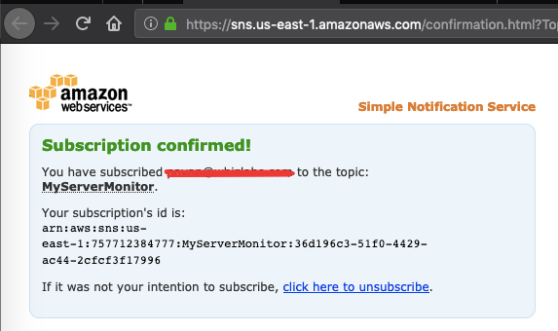
- Leave the other settings as default and click on Next.
- On the next screen, configure the alarm name as shown below:
  - Alarm name: Enter Alert_for_lambda_invokation_error
  - Alarm description: Enter Alert for failure of lambda function execution
- Click on the Next button. Finally, in the Preview and Create tab, review the given details and click on Create alarm
10. Navigate to the CloudWatch dashboard to see that the alarm created in the above step is labeled as insufficient as shown below:
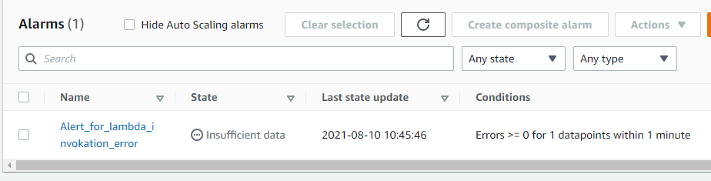

Task 5: Testing the Metric
- In this section, we will test the CloudWatch alarm when the Lambda invocation fails.
- To test, go to the Services menu and select Lambda from Compute category.
- Select the function named Mytestlambdafunction (created in earlier steps).
- Scroll down a little and make a change in the code that throws an error. For example, you can replace the existing codes with this one:
import json
def lambda_handler(event, context):
# TODO implement
return {
'statusCode': 200,
'body': json.dumps('Hello from Lambda!')
Here is the error in the code
}
- Click on Deploy the button and then click on Test. You should see the below error message:
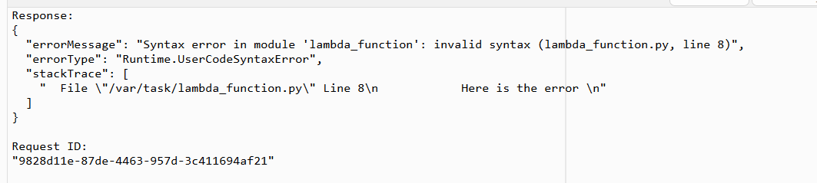
- Now open the email account you used for the SNS topic and you will see an Email notification for a failed invocation of your Lambda function, as shown below:
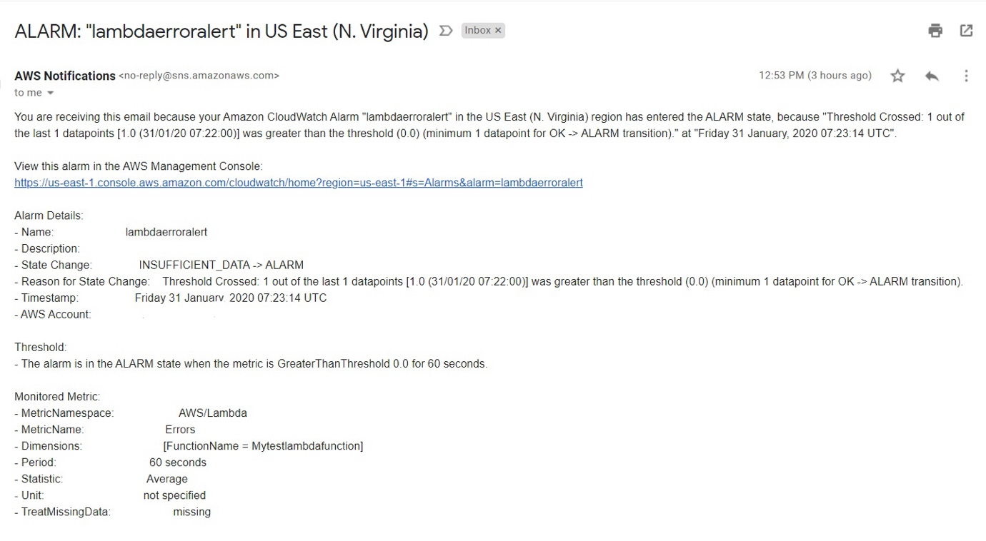
- Now navigate to the CloudWatch dashboard where you will see the alarm in the alarm state, as shown below:
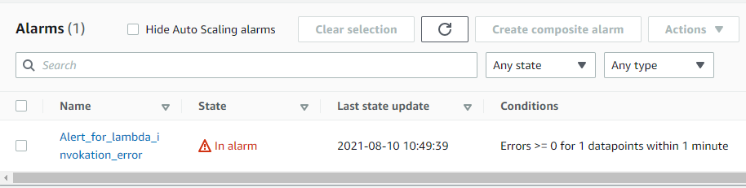
- We have now confirmed the CloudWatch alarm works as expected.
Note: It’ll take a minute or more for the SNS notification to be sent and the state to change to In-Alarm.

POLICY:

{
"Version": "2012-10-17",
"Statement": [
{
"Effect": "Allow",
"Action": [
"logs:CreateLogGroup",
"logs:CreateLogStream",
"logs:PutLogEvents"
],
"Resource": "*"
}
]
}

